RadScope

Edge-Set V1

RS-EDGE001 &
RS-AD001

RadScape Series: Handheld Radioisotope Identification
Advanced Embedded Platform for Real-time Radiation Analysis

1. System Overview
The RadScape Series is a modular hardware solution designed for high-precision radiation monitoring and isotope identification. By integrating the powerful RS-EDGE001 controller with the high-sensitivity RS-AD001 ADC board, it provides a laboratory-grade analysis environment in a portable handheld form factor.

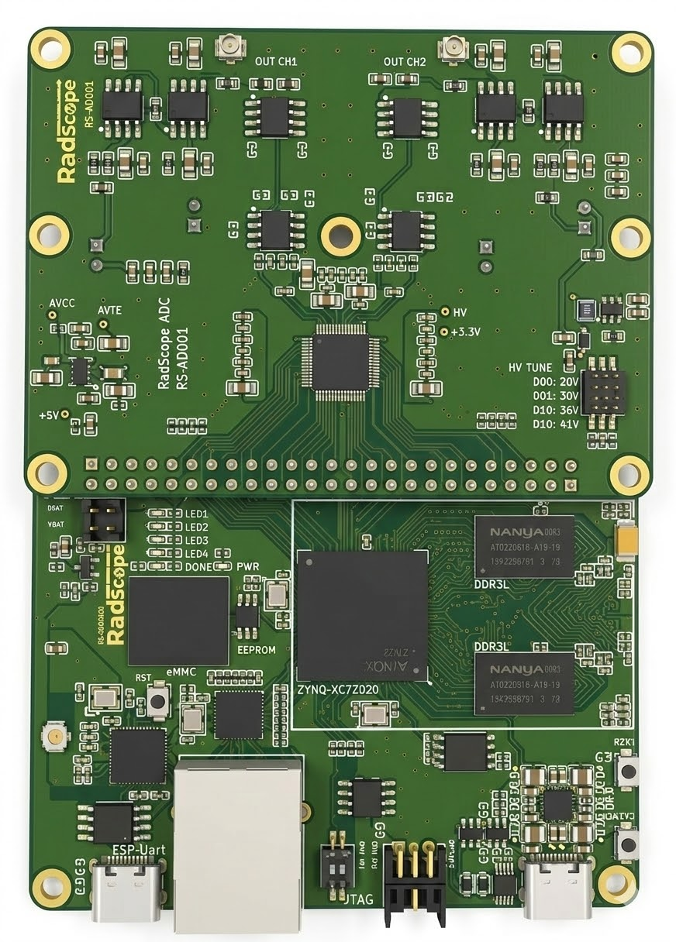

2. RS-EDGE001 (Main Control Board)
"The Intelligence Center for Seamless Data Processing"
The RS-EDGE001 serves as the brain of the system, managing complex algorithms and user interactions.
- High-Performance Processing: Optimized for real-time spectroscopic data analysis.
- Wireless Connectivity: Integrated WiFi for instant data logging and remote cloud synchronization.
- User-Centric Interface: Fully supports Capacitive Touch LCD for intuitive on-site operations.
- Ultra-Compact Design: Tailored for handheld devices with a focus on power efficiency.

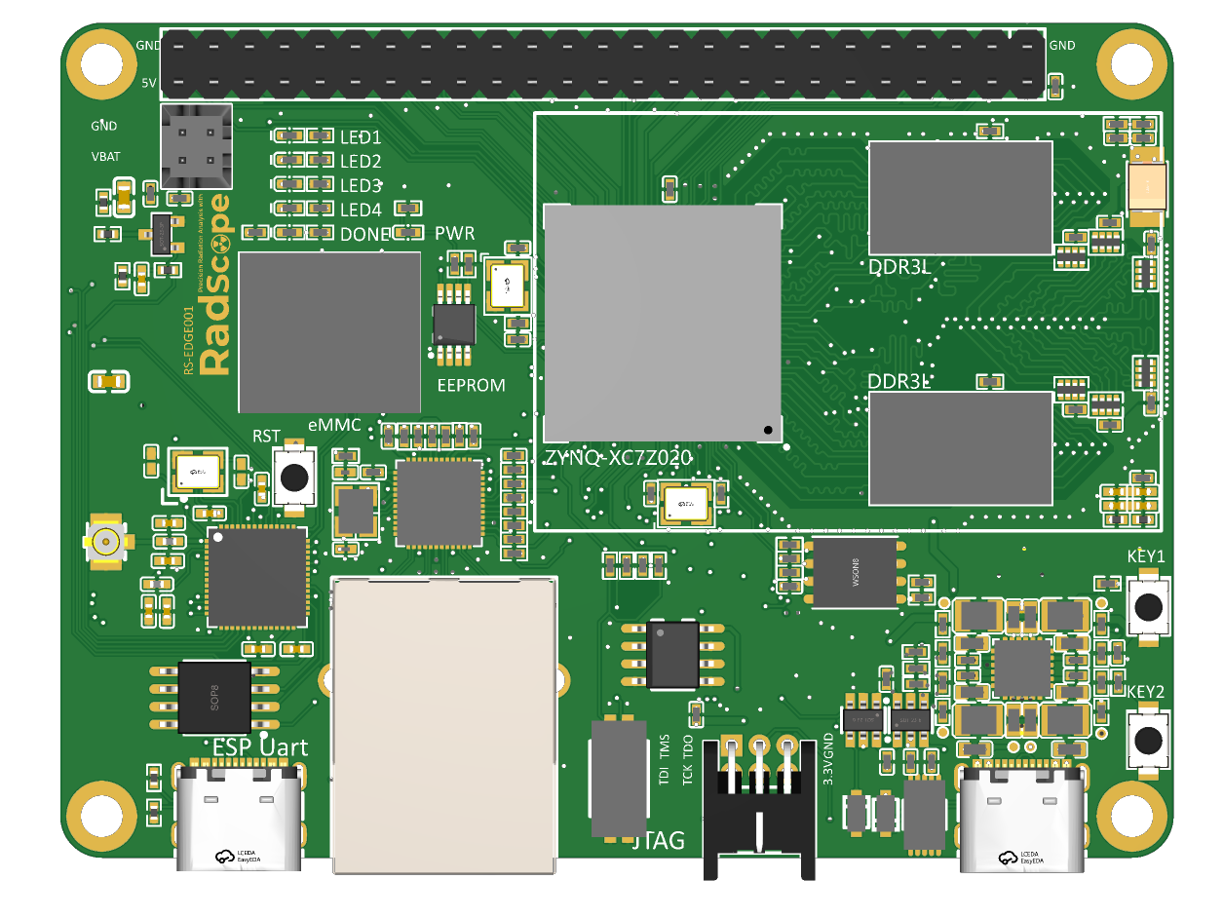
RS-EDGE001 Front View
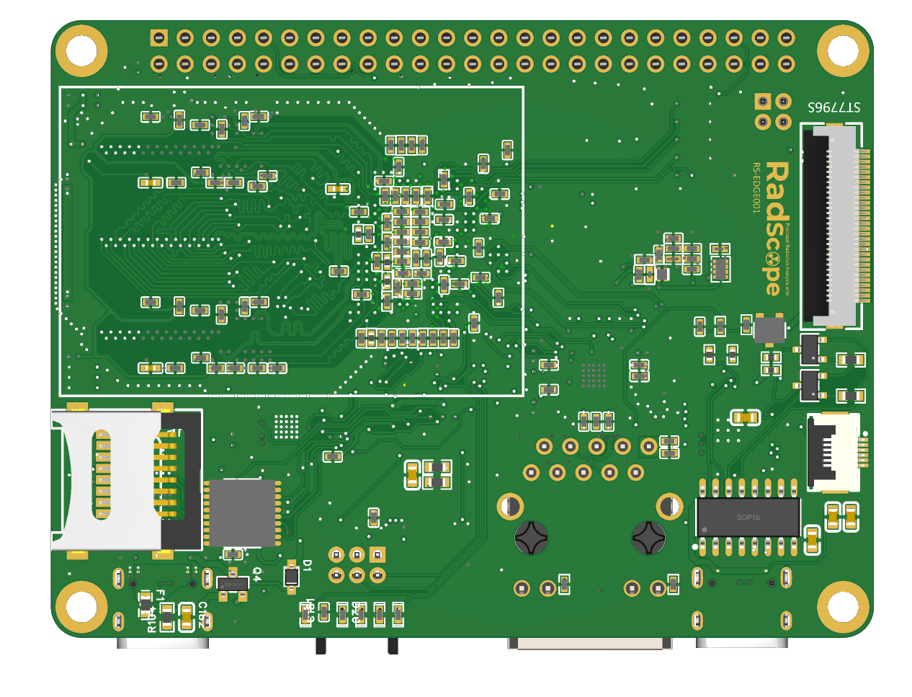
RS-EDGE001 Back View

High-Density Integration for Field Mobility The rear layout of the RS-EDGE001 showcases a compact, high-density design optimized for handheld integration. It features an efficient power management circuit and high-speed data interface connectors to ensure stable performance under various field conditions.
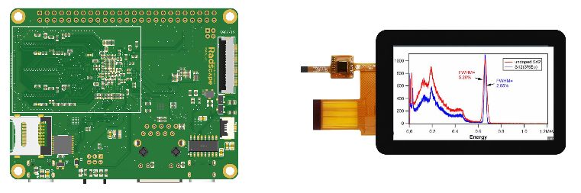

Intuitive UI with Real-time Spectrum Visualization The integrated capacitive touch LCD provides a crisp, responsive interface for on-site operators. It displays high-resolution energy spectrums (MCA data) with clear peak identification and FWHM (Full Width at Half Maximum) analysis, allowing for immediate isotope verification.

3. RS-AD001 (High-Performance ADC Board)
"Precision Signal Acquisition for Reliable Detection"
The RS-AD001 is a specialized analog-to-digital conversion module that captures delicate radiation signals with extreme clarity.
- Dual-Channel ADC: Supports synchronized 2-channel sampling for comprehensive signal tracking.
- SiPM Optimized Interface: Features dedicated sockets for Broadcom AFBR-S4E001 SiPM modules (Cathode/Anode).
- Low-Noise Analog Front-End: Engineered to minimize signal interference, ensuring superior energy resolution.
- Plug-and-Play Stacking: Seamlessly connects to the RS-EDGE001 via high-density headers.
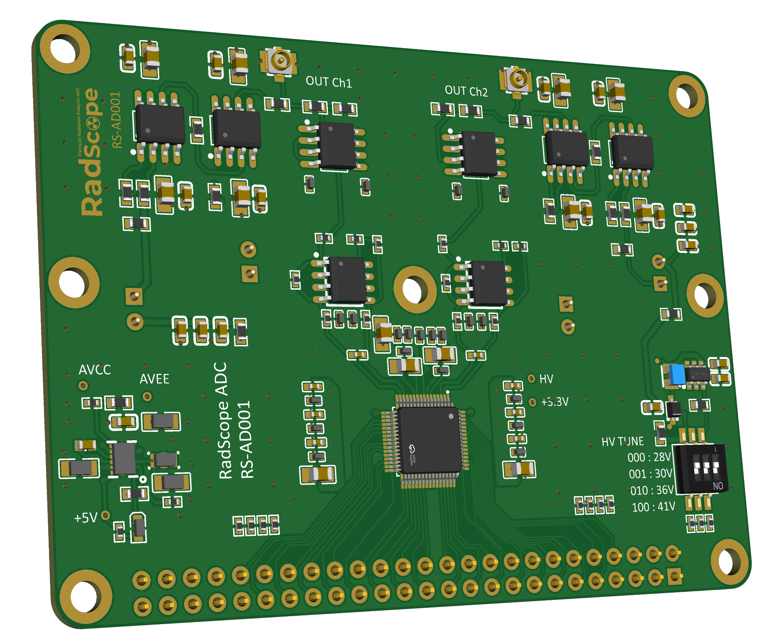
RS-AD001 Front View
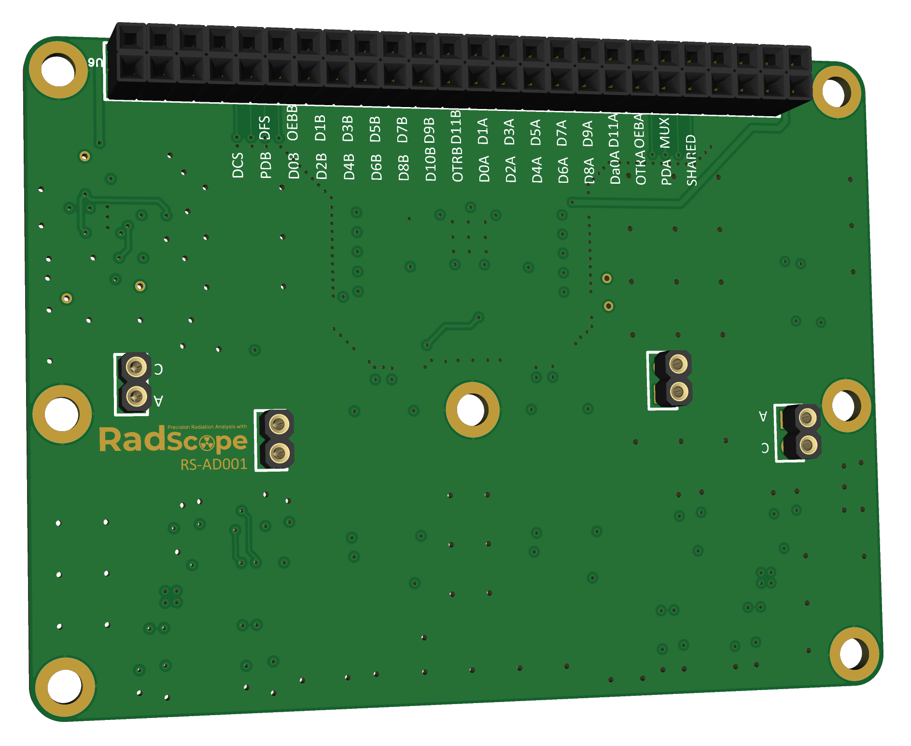
RS-AD001 Back View
Real-time Signal Verification Port
- Integrated Probing Points: Features dedicated test ports to monitor pre-amplifier output signals directly.
- On-site Debugging: Allows developers and researchers to verify signal integrity using an oscilloscope without disassembling the device.
- High-Fidelity Monitoring: Ensures that the raw pulse signal from the SiPM is being processed correctly before digital conversion.

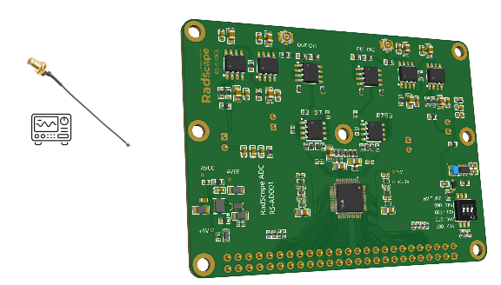
Direct Oscilloscope Interface: Monitoring the pre-amplifier output for precise signal tuning.
"Transparency in Signal Processing: The RS-AD001 provides direct access to pre-amp signals, enabling perfect calibration and real-time diagnostic capabilities in any environment."

4. Key Specifications

Feature | Description | Benefit
Isotope Identification | Real-time peak detection and library matching | Rapid threat assessment in the field
Connectivity | WiFi, UART, and GPIO Expansion | Versatile integration with various peripherals
Visualization | High-resolution Energy Spectrum Graph | Clear, actionable data for the operator
Sensor Support | Direct SiPM Module Mounting | Minimized signal path for better accuracy

5. Technical Guide: SiPM Connection
To ensure the highest measurement accuracy, please follow the connection protocol for the Broadcom AFBR-S4E001 SiPM:
- Align the module pins with the C (Cathode) and A (Anode) sockets on the RS-AD001.
- Insert firmly to ensure secure electrical contact and correct polarity.
